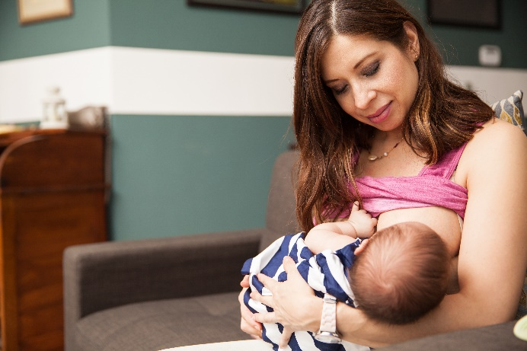

National Breastfeeding Month

Social Media Toolkit | August 2020

In recognition of National Breastfeeding Month, we’ve put together a collection of social media posts and graphics that can be used to raise awareness about the importance and benefits of breastmilk, as well as empower and support all mothers to achieve their breastfeeding goals.
National Breastfeeding Month is celebrated to advance advocacy, protection and promotion of breastfeeding to ensure that all families have the opportunity to breastfeed.
When posting, use the hashtag #NationalBreastfeedingMonth and tag @NICHQ so we can like and share your post.

Social Media Posts

- Mothers need a safe, clean and private area to breastfeed or pump. Having these environments in the workplace can help mothers reach their breastfeeding goals after they’ve returned to work: https://www.cdc.gov/breastfeeding/pdf/BF_guide_2.pdf

- Mothers can still breastfeed and keep their baby safe during the COVID-19 pandemic. Here, the @CDC is providing safety guidelines and recommendations as information about breastfeeding and COVID-19 continue to evolve. https://www.cdc.gov/breastfeeding/breastfeeding-special-circumstances/maternal-or-infant-illnesses/covid-19-and-breastfeeding.html

- Breastmilk is the best source of nutrition for most babies, providing a variety of vitamins and minerals that help babies grow big and strong! Empower mothers to learn about the benefits of breast milk:
https://www.cdc.gov/nutrition/InfantandToddlerNutrition/breastfeeding/index.html

- The @CDC shares tips on how to provide both prenatal and postpartum support to transgender parents who wish to breastfeed or chestfeed their infant: https://www.cdc.gov/breastfeeding/breastfeeding-special-circumstances/maternal-or-infant-illnesses/breast-surgery.html

- Mothers can have many concerns about breastfeeding, especially in the early days. As health care professionals, it’s important to learn about the common challenges mothers experience so you can provide the support they need. https://www.womenshealth.gov/breastfeeding/breastfeeding-challenges/common-breastfeeding-challenges

- Not only does rooming-in have the potential to improve health outcomes for mothers and babies, it also has the potential to reduce racial disparities in breastfeeding. Learn more about how this strategy can improve rates of breastfeeding for all: https://www.nichq.org/insight/interrupting-mother-childdyad-not-answer-infant-safety

- Younger moms (aged 20 to 29 years) and adolescent mothers are less likely to ever breastfeed than mothers aged 30 years or older. Building resiliency in young moms can improve breastfeeding and save babies. https://www.nichq.org/insight/building-resiliency-teen-moms-can-improve-breastfeeding-and-save-babies

- Reducing racial and ethnic disparities in breastfeeding starts with providing families with education and support services that meet their social, cultural and linguistic needs. Learn how cultural sensitivity improves breastfeeding outcomes: https://www.nichq.org/insight/cultural-sensitivity-better-breastfeeding-outcomes

- It’s not always easy for mothers to get the support they may need while breastfeeding. Read how telelactation can provide mothers with online lactation consultants, support groups and other essential resources: https://www.nichq.org/insight/bringing-breastfeeding-support-more-mothers-and-caregivers

- Peer and family networks can improve breastfeeding rates among Black women. Learn how these networks can fill a gap in breastfeeding support for Black women—a gap largely created by the historic and systemic inequities: https://www.nichq.org/insight/breastfeeding-takes-village-and-too-often-black-women-dont-have-one
Graphics
To save these graphics, exit “Read Only” mode, right click on each graphic and click “Save as Picture” to download!

**Avoid copy/pasting or screen-shots**
This will cause the image to be blurry when shared on social media
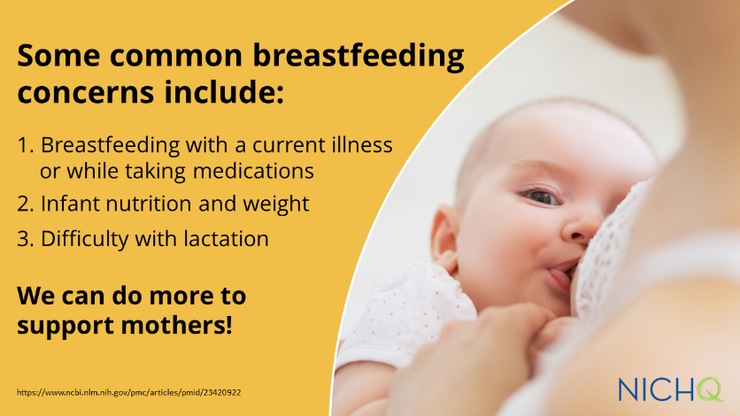
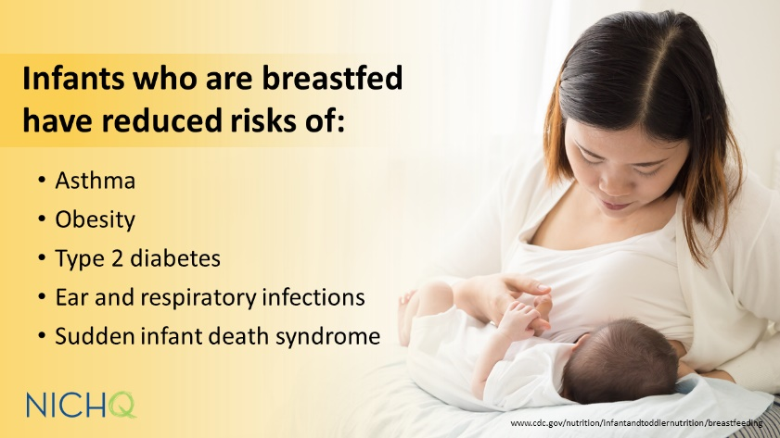
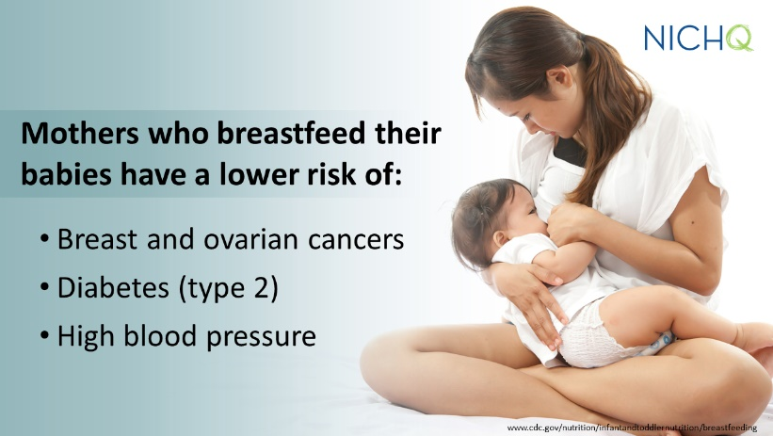
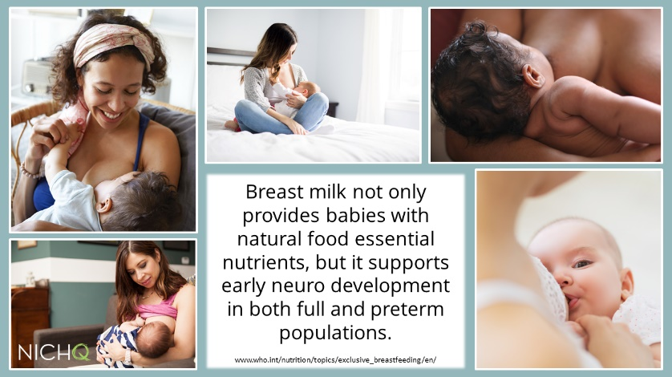
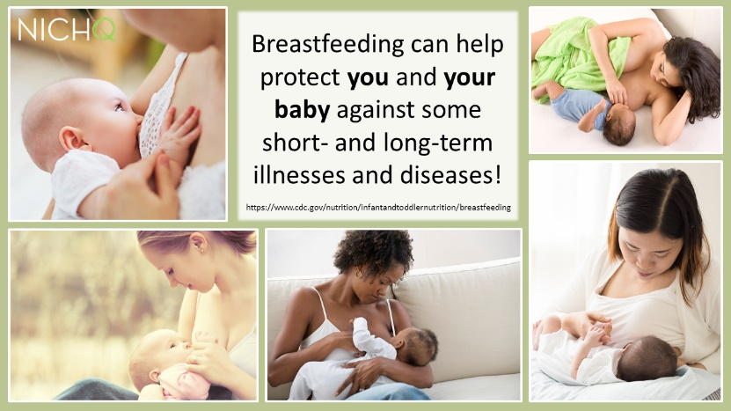
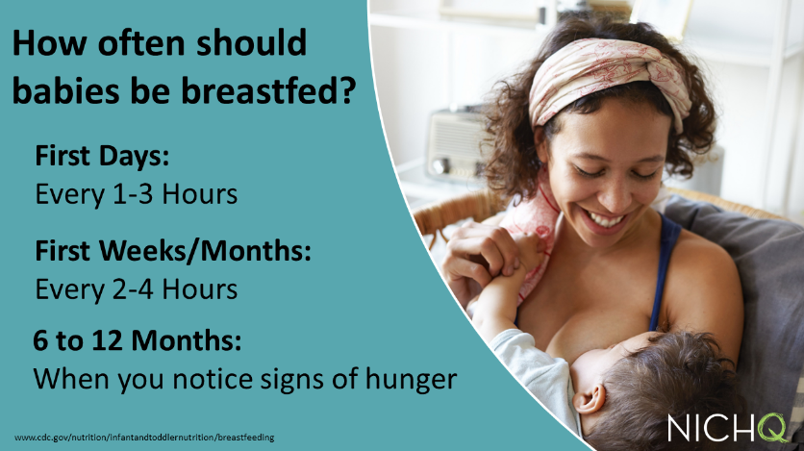
z

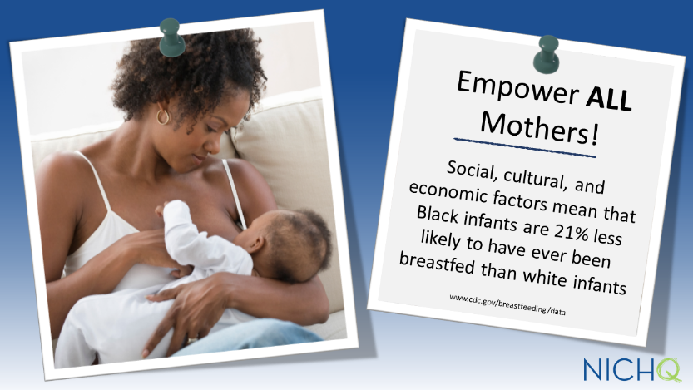
Download these graphics to use on your own social channels, and make sure to tag @NICHQ so we can like and share your post.

